Yagi Antenna – Gamma Match and Dipole Construction

# Gamma Match

Firstly for the issue of gamma matching the yagi’s driven element it really depends on whether we decide to do the folded dipole or not. What I found is that a gamma match is just another way of matching the feed impedance of the antenna similar to a delta match or the folded dipole we are planning on. At this point I am not sure what would occur if we attached a gamma match to a folded dipole since most sources imply only one or the other is in use on the antenna.

Here is a good source that explains some of the disadvantages and advantages of the different ways of matching feed impedance. <http://www.radio-electronics.com/info/antennas/yagi/yagi-feed-impedance-matching.php>

Furthermore; I found a series of videos in which they build a yagi antenna with a gamma match instead of a folded dipole and explain some of the fine tuning that is required with a gamma match in order to hit a 1:1 SWR. (The videos are in Spanish but I can understand his explanation)

<https://youtu.be/ND7QngMSgLM> (The construction of his Yagi which differs only in the fact he does not use a folded dipole in the driven element. Uses aluminum for all the elements with a wooden beam similar to what we have planned)

<https://youtu.be/lAAxhFdsMzI> (He explains some of the assembly specifics of the gamma match portion of his yagi which would only require a bit more coax cable from that which we are ordering)

<https://youtu.be/FSvpdT71724> (He spends the video fine tuning the gamma match in order to receive the appropriate SWR which would be something we would have to do as well if we decide to go with the gamma match instead of the folded dipole. I emailed the guy in the video but he seems to have up a paywall for his help )

From some of the forums I have been visiting people tend to neither really favor a folded dipole over a gamma match since both serve the same purpose but the gamma match can be more complicated to tune. Here is a forum where this is discussed and it explains how the impedance tuning comes down to the movement of the electrical short strap. <http://ham.stackexchange.com/questions/1804/what-is-a-gamma-match-in-the-context-of-the-driven-element-of-a-yagi-antenna>

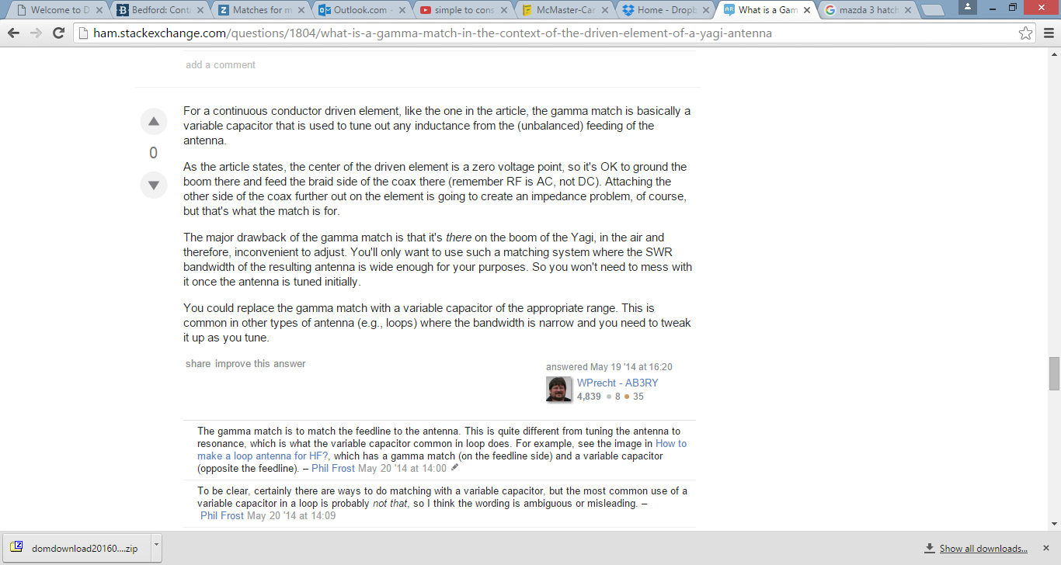

# Folded Dipole Construction

If we do decide on continuing with the folded dipole rather than the gamma match the jig would have to have a very specific pulley roller on the inside bend in order to achieve the correct bend diameter (35mm) and also hold the correct OD of the copper tube you have (3/8” – 9.53mm). I have not found a pulley with the correct dimensions after looking in the Mcmaster Carr section of round belt pulleys. I am pretty sure that if we are just bending copper tubing we can get away with 3D printing the inside roller at full density and it would give us the exact bend diameter and hold the 3/8 pipe diameter. I already drew the roller we would require for the jig. I left the bore of the pulley empty as I am still drawing the rest of the jig but it won’t take me long.

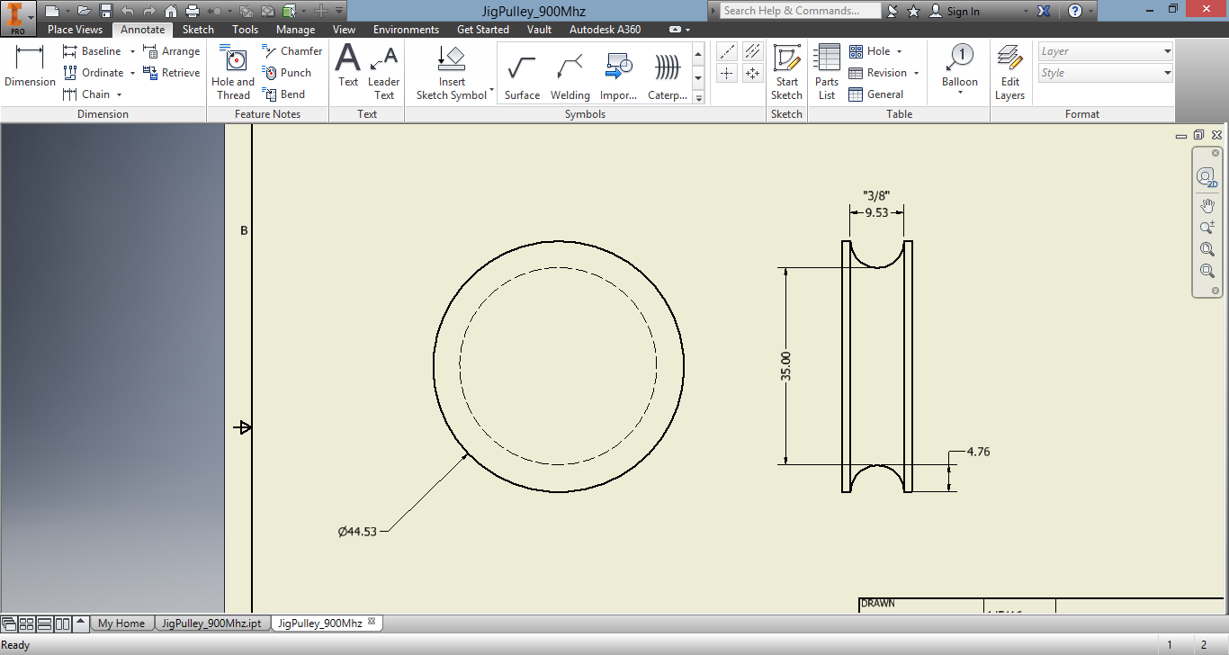

Also here is a neat animation I found that illustrates the simple tube bender I have in mind in order to construct a folded dipole

<https://youtu.be/PqZoEd8iNjk>